Note: Make sure the correct USB to serial driver is installed in the game terminal

Configuration

Step 1:  use **Acceptor tool** with USB Flash Download Cable (05AA0026 ) to select the correct Interface and Bill table.

<http://shop.pyramidacceptors.com/usb-flash-download-cable-for-pc-05aa0026/>

1. select configure tab in the right side
2. Check RS-232  + Solid On Enabled  + select all bills
3. Click on send button

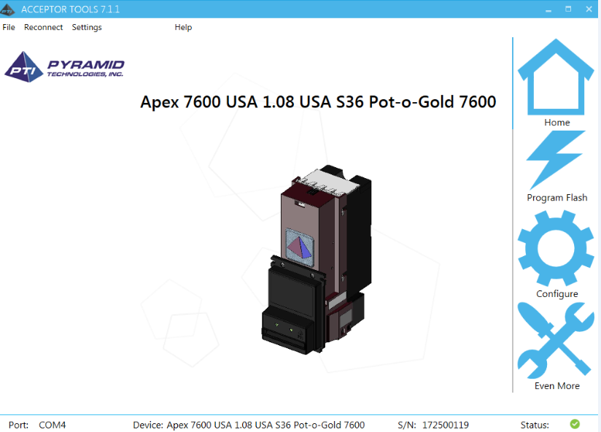

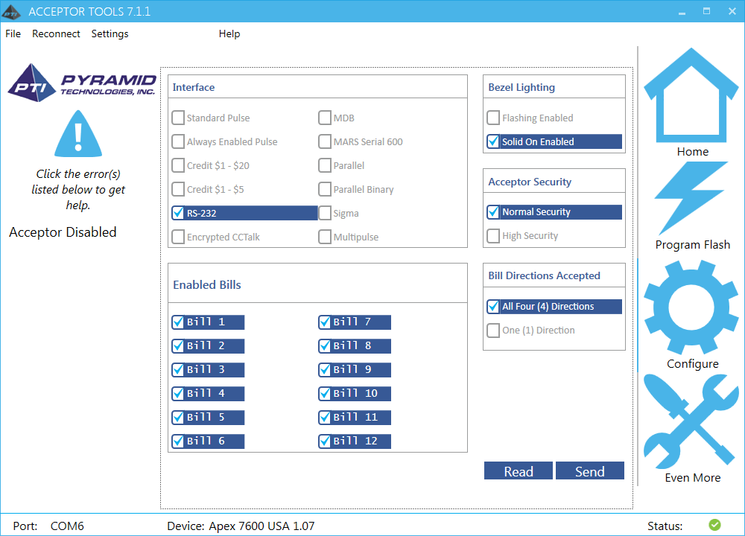

Step 2:  Test with RS-232 Sample Application with communication USB to serial cable (05AA0023)

<http://shop.pyramidacceptors.com/usb-rs-232-communication-cable-harness-for-apex-05aa0023/>

* 1. Recycle the power
  2. Select correct port
  3. click on connect

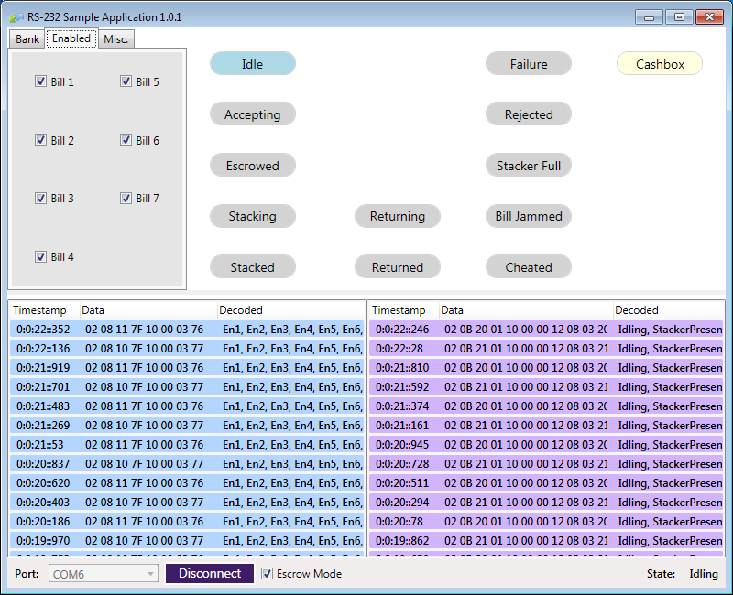

Step 3 – Test with System code with correct hardware.xml

                <PORT

                                type="BILL"

                                port="COM6"

                                device_type="PTI"

                                bill_map="100 200 500 1000 2000 5000">

                </PORT>